Miranda_Belmonte_Hairo_tarea1

Miranda Belmonte Hairo

10 de septiembre de 2016

EJERCICIO 1

library(astsa)  
  
class(jj)

## [1] "ts"

?jj

## starting httpd help server ...

## done

1. Lo que mide la serie son : Quarterly Earnings Per Share 84 quarters (21 years) measured from the first quarter of 1960 to the last quarter of 1980.

b)inicio, fin y frecuencia de la serie

end(jj)

## [1] 1980 4

start(jj)

## [1] 1960 1

frequency(jj)

## [1] 4

cycle(jj)

## Qtr1 Qtr2 Qtr3 Qtr4  
## 1960 1 2 3 4  
## 1961 1 2 3 4  
## 1962 1 2 3 4  
## 1963 1 2 3 4  
## 1964 1 2 3 4  
## 1965 1 2 3 4  
## 1966 1 2 3 4  
## 1967 1 2 3 4  
## 1968 1 2 3 4  
## 1969 1 2 3 4  
## 1970 1 2 3 4  
## 1971 1 2 3 4  
## 1972 1 2 3 4  
## 1973 1 2 3 4  
## 1974 1 2 3 4  
## 1975 1 2 3 4  
## 1976 1 2 3 4  
## 1977 1 2 3 4  
## 1978 1 2 3 4  
## 1979 1 2 3 4  
## 1980 1 2 3 4

1. Grafica de las series

start(jj)

## [1] 1960 1

plot(jj, main= "Qrts", xlab = "Tiempo", ylab = "")

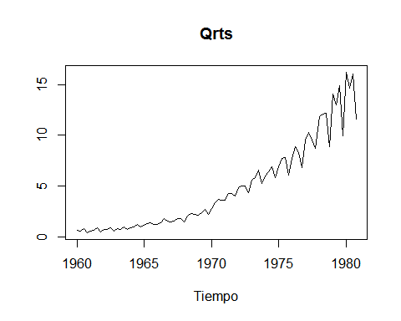

ljj<-log(jj)  
plot(ljj, main= "Qrts", xlab = "Tiempo", ylab = "")

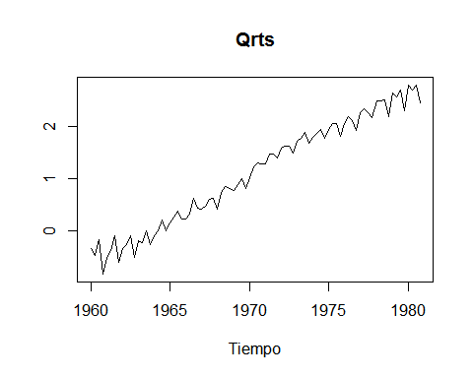

Se toman Logs dado el comportamiento de tendencia estocastica

timp=as.numeric(time(ljj))  
  
fit=lm(ljj~timp)

lines(timp,fit$fitted.values,col="red",lty=2,lwd=2)

fit

##   
## Call:  
## lm(formula = ljj ~ timp)  
##   
## Coefficients:  
## (Intercept) timp   
## -327.5476 0.1668

Un incremento de un aqo en el tiempo, aumentaria en .16 por ciento en promedio la ganancia por accisn en promedio.

residuos <- resid(fit)  
plot(residuos,type="l")  
library(forecast)

## Loading required package: zoo

##   
## Attaching package: 'zoo'

## The following objects are masked from 'package:base':  
##   
## as.Date, as.Date.numeric

## Loading required package: timeDate

## This is forecast 7.1

##   
## Attaching package: 'forecast'

## The following object is masked from 'package:astsa':  
##   
## gas

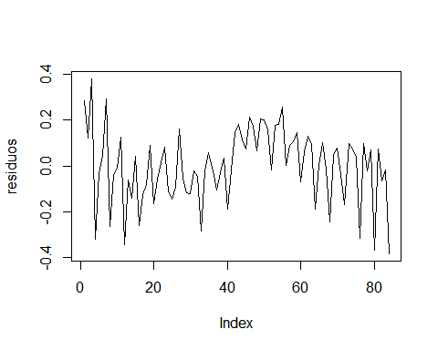

tsdisplay(residuos)

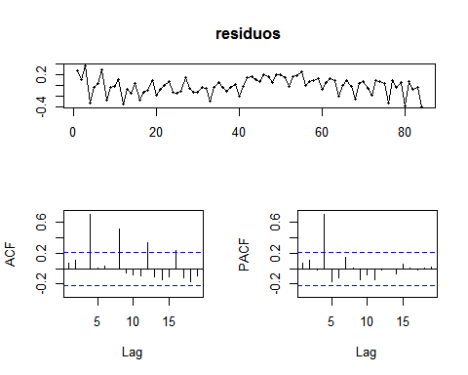 FIN DE EJERCICIO 1

EJERCICIO 2 Utilice las series cmort, part y tempr de su espacio de trabajo

1. Investigue qui es cada cosa

?cmort  
start(cmort)

## [1] 1970 1

end(cmort)

## [1] 1979 40

?part  
start(part)

## [1] 1970 1

end(part)

## [1] 1979 40

?tempr  
start(tempr)

## [1] 1970 1

end(tempr)

## [1] 1979 40

Cardiovascular Mortality from the LA Pollution study (cmort) Particulate levels from the LA pollution study (part) Temperatures from the LA pollution study(tempr)

1. Utilice los datos para ajustar el modelo cmortt = a+_1t+_2temprt +_3tempr2 t +_4partt

tiemp=as.numeric(time(cmort))  
mod<-lm(cmort ~ tiemp + tempr + I(tempr^2) + part)  
mod

##   
## Call:  
## lm(formula = cmort ~ tiemp + tempr + I(tempr^2) + part)  
##   
## Coefficients:  
## (Intercept) tiemp tempr I(tempr^2) part   
## 2991.14024 -1.39590 -3.82726 0.02259 0.25535

sumod<-summary(mod)  
lim.sup.alpha<-2.991e+03+1.994e+02*1.96  
lim.inf.alpha<-2.991e+03-(1.994e+02*1.96)  
alpha<-2.991e+03   
alph<-c(lim.inf.alpha,alpha,lim.sup.alpha)  
  
lim.sup.tiemp<--1.396e+00 +1.010e-01*1.96  
lim.inf.tiemp<--1.396e+00 -(1.010e-01*1.96)  
tiemp<--1.396e+00   
tiempo<-c(lim.inf.tiemp,tiemp,lim.sup.tiemp)  
  
lim.sup.tempr<--3.827e+00 + 4.236e-01*1.96  
lim.inf.tempr<--3.827e+00 -( 4.236e-01*1.96)  
tempr<--3.827e+00  
temp<-c(lim.inf.tempr,tempr,lim.sup.tempr)  
  
lim.sup.tempr2<- 2.259e-02 + 2.827e-03*1.96  
lim.inf.tempr2<- 2.259e-02 -( 2.827e-03*1.96)  
tempr2<- 2.259e-02  
temp2<-c(lim.inf.tempr2,tempr2,lim.sup.tempr2)  
  
lim.sup.part<- 2.554e-01 + 1.886e-02*1.96  
lim.inf.part<- 2.554e-01 -( 1.886e-02*1.96)  
part<- 2.554e-01  
par<-c(lim.inf.part,part,lim.sup.part)  
  
resid<-resid(mod)  
tsdisplay(resid)

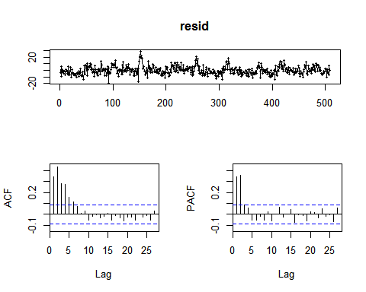 Correlación en los residuales.

mod2<-dyn$lm(cmort ~ tiemp + tempr + I(tempr^2) + part + lag(part, 4)) sum_mod2<-summary(mod2)

sumod2<-summary(mod2) lim.sup.alpha<-3.012e+03+1.945e+02 *1.96 lim.inf.alpha<-3.012e+03-1.945e+02* 1.96 alpha<-3.012e+03 alph<-c(lim.inf.alpha,alpha,lim.sup.alpha)

lim.sup.tiemp<- -1.400e+00 + 9.843e-02*1.96 lim.inf.tiemp<- -1.400e+00 - 9.843e-02*1.96 tiemp<- -1.400e+00 tiempo<-c(lim.inf.tiemp,tiemp,lim.sup.tiemp)

lim.sup.tempr<--4.064e+00 + 4.102e-01*1.96 lim.inf.tempr<--4.064e+00 - 4.102e-01*1.96 tempr<--4.064e+00 temp<-c(lim.inf.tempr,tempr,lim.sup.tempr)

lim.sup.tempr2<- 2.408e-02 + 2.737e-03*1.96 lim.inf.tempr2<- 2.408e-02 - 2.737e-03*1.96 tempr2<- 2.408e-02 temp2<-c(lim.inf.tempr2,tempr2,lim.sup.tempr2)

lim.sup.part<- 3.302e-01 + 2.146e-02*1.96 lim.inf.part<- 3.302e-01 - 2.146e-02*1.96 part<- 3.302e-01 par<-c(lim.inf.part,part,lim.sup.part)

lim.sup.part4<- -1.406e-01 + 2.153e-02 *1.96 lim.inf.part4<- -1.406e-01 - 2.153e-02* 1.96 part4<- -1.406e-01 par4<-c(lim.inf.part4,part4,lim.sup.part4)

resid2<-resid(mod2) library(forecast) tsdisplay(resid2) ``` Residuales con Correlacionados

FIN DE EJERCICIO 2

EJERCICIO 3

Utilice la serie oil y gas a. Describa qu(& mide cada serie de tiempo

?oil  
?gas  
class(oil)

## [1] "ts"

class(gas)

## [1] "ts"

end(gas)

## [1] 1995 8

start(gas)

## [1] 1956 1

end(oil)

## [1] 2010 25

start(oil)

## [1] 2000 1

frequency(oil)

## [1] 52

frequency(gas)

## [1] 12

oil: Crude oil, WTI spot price FOB (in dollars per barrel), weekly data from 2000 to mid-2010.

gas:New York Harbor conventional regular gasoline weekly spot price FOB (in cents per gallon) from 2000 to mid-2010.

1. Aplique la transformaci(.n

oil.cp<-diff(log(oil))  
gas.cp<-diff(log(gas))  
par(mfrow=c(2,1))  
plot(oil.cp)  
plot(gas.cp)

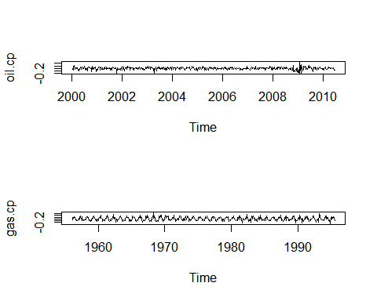

1. Gra023que la funci(.n de correlaci(.n cruzada entre estas serie con ccf().

help(ccf)  
par(mfrow=c(1,1))  
ccf(oil.cp,gas.cp,plot =FALSE, lag.max = 5)  
ccf(oil.cp,gas.cp, lag.max = 5, ylab = "cross-correlation")

Valores significativos: lag 1 lag 3

1. Utilice la funci(.n lag2.plot() para analizar el efecto sobre oil.pc de gas.pc con hasta 3 semanas de retardo.

help("lag2.plot") library(stats) lag2.plot(oil.cp,gas.cp,max.lag = 2)

Parecen relaciones lineales? No. Parecen relaciones estables o signi023cativas? La contemporanea solamente

oil

## Time Series:  
## Start = c(2000, 1)   
## End = c(2010, 25)   
## Frequency = 52   
## [1] 26.20 26.07 26.34 24.95 26.27 29.37 28.34 28.08 28.83 29.87  
## [11] 30.10 31.07 32.14 31.29 27.99 26.92 25.60 24.87 26.66 25.95  
## [21] 26.75 28.70 29.88 29.46 29.98 29.79 32.45 33.55 32.12 30.40  
## [31] 30.44 30.65 28.02 28.50 30.14 31.82 32.46 33.08 34.42 34.70  
## [41] 35.49 31.13 31.27 33.90 33.48 33.92 32.78 33.46 35.00 35.91  
## [51] 34.10 29.69 29.05 27.38 26.52 27.80 28.81 30.63 31.35 29.59  
## [61] 30.92 29.67 28.65 27.91 28.45 27.02 26.42 26.86 26.76 28.27  
## [71] 27.89 26.99 28.36 28.12 29.08 28.92 28.44 27.98 28.90 27.09  
## [81] 26.37 26.87 27.07 25.26 26.50 27.10 27.87 27.52 27.25 26.84  
## [91] 27.38 28.22 27.09 22.35 22.60 22.66 21.92 21.78 21.17 20.70  
## [101] 19.61 18.28 19.13 19.47 18.45 19.20 20.94 20.80 20.54 18.61  
## [111] 19.21 19.71 19.97 21.18 20.70 21.43 23.31 24.40 25.25 25.86  
## [121] 26.99 25.24 25.54 26.46 26.88 27.27 28.43 27.18 25.22 25.01  
## [131] 24.94 25.61 26.52 26.81 26.70 27.62 26.64 26.87 26.77 28.52  
## [141] 30.09 28.84 28.65 29.59 29.39 30.63 30.25 29.37 29.65 27.88  
## [151] 27.03 25.97 25.68 26.98 26.83 27.14 27.82 30.35 32.38 31.96  
## [161] 31.54 33.04 34.46 33.19 33.95 35.79 36.78 36.98 36.98 36.66  
## [171] 30.46 30.43 29.33 28.03 29.28 28.43 25.69 26.58 28.54 29.29  
## [181] 29.10 30.68 31.46 30.60 30.01 30.31 30.73 31.48 30.61 30.73  
## [191] 32.11 31.31 31.19 31.56 29.20 28.92 27.39 27.73 29.43 30.69  
## [201] 31.49 30.17 29.28 29.79 31.56 32.58 30.11 30.63 32.16 33.20  
## [211] 32.24 32.68 33.89 34.51 35.45 33.61 33.41 33.88 35.54 36.08  
## [221] 36.67 36.44 37.78 36.65 35.23 35.70 37.39 37.32 37.31 39.24  
## [231] 40.37 40.84 40.65 40.01 37.99 37.86 37.70 37.14 39.73 40.33  
## [241] 41.27 42.50 43.81 45.24 47.28 44.34 43.28 43.33 44.39 47.82  
## [251] 49.71 51.77 54.12 54.43 53.43 49.81 48.00 47.02 48.79 46.06  
## [261] 41.91 43.50 44.39 42.52 44.07 46.79 47.85 48.56 46.97 46.08  
## [271] 47.82 51.75 52.74 54.22 55.93 52.95 54.97 55.24 51.44 52.39  
## [281] 52.00 50.64 50.33 47.77 50.15 53.76 53.74 56.18 59.04 58.21  
## [291] 60.36 59.18 57.30 59.39 61.64 64.85 64.92 66.34 68.47 64.81  
## [301] 63.84 66.43 66.06 63.06 62.87 62.28 61.33 60.34 58.80 57.00  
## [311] 58.13 57.78 59.83 60.32 57.97 59.82 63.39 63.74 66.79 66.82  
## [321] 66.59 63.06 59.37 59.93 62.27 60.89 62.64 61.36 65.67 66.56  
## [331] 68.85 71.87 70.38 72.14 71.50 69.07 70.35 71.53 71.54 69.48  
## [341] 69.94 72.65 74.65 75.21 73.98 73.87 75.20 75.63 71.79 72.12  
## [351] 70.01 67.53 63.98 61.40 61.94 59.77 58.58 58.48 58.88 58.55  
## [361] 59.96 57.56 57.24 62.02 62.32 61.91 62.40 60.66 57.76 54.11  
## [371] 51.51 53.57 57.11 58.99 58.41 59.57 61.64 60.85 57.94 58.26  
## [381] 64.18 64.82 62.58 63.06 65.26 63.82 61.90 63.61 64.89 63.94  
## [391] 65.90 66.62 68.78 69.13 71.78 72.79 74.92 75.15 76.75 71.92  
## [401] 72.05 70.19 72.93 75.96 78.95 82.26 81.70 80.59 81.46 87.80  
## [411] 89.23 93.46 95.81 93.56 97.93 92.47 88.71 91.18 91.16 95.64  
## [421] 98.17 94.76 91.51 89.41 91.14 89.08 94.13 99.61 100.84 103.44  
## [431] 109.35 105.28 104.49 103.46 109.71 114.33 118.53 115.42 123.01 124.96  
## [441] 130.14 128.47 128.16 134.80 134.34 137.00 142.52 139.95 135.37 125.92  
## [451] 124.57 118.80 114.40 115.70 116.09 108.37 102.88 97.19 111.12 96.59  
## [461] 86.24 75.19 68.56 65.21 64.31 58.60 52.26 53.27 45.60 44.57  
## [471] 39.70 32.98 42.40 44.46 36.73 42.15 42.70 40.78 36.94 37.15  
## [481] 41.10 43.18 45.66 49.49 52.99 50.34 50.46 49.86 47.80 50.20  
## [491] 55.96 57.94 60.32 64.32 68.11 70.85 70.62 68.58 69.32 61.48  
## [501] 61.29 65.28 67.03 71.58 69.64 70.80 72.37 68.39 70.91 71.32  
## [511] 68.33 68.84 70.80 75.73 80.06 78.47 79.00 78.24 78.37 76.14  
## [521] 76.81 71.51 71.72 74.76 79.07 82.34 80.06 76.62 73.94 74.57  
## [531] 73.88 78.25 79.22 80.19 81.76 81.44 80.65 83.01 85.66 84.34  
## [541] 82.90 84.22 80.24 74.98 69.14

detach(package:forecast)  
gas

## Time Series:  
## Start = c(2000, 1)   
## End = c(2010, 25)   
## Frequency = 52   
## [1] 70.636 71.040 68.490 65.137 67.918 75.117 72.970 76.106  
## [9] 78.158 82.272 83.902 96.146 94.470 89.112 82.782 83.912  
## [17] 74.008 68.426 75.170 74.320 82.572 86.412 91.476 91.034  
## [25] 97.552 94.630 98.324 95.482 96.576 82.880 91.124 87.964  
## [33] 80.346 85.380 82.282 87.350 88.630 94.028 101.290 96.904  
## [41] 97.232 89.716 85.928 94.558 96.996 101.716 94.998 94.350  
## [49] 94.970 97.862 88.718 75.120 72.482 71.674 73.380 78.395  
## [57] 84.566 84.410 84.062 83.138 86.920 82.914 78.695 78.066  
## [65] 78.876 76.220 78.430 80.806 88.142 95.777 97.492 96.742  
## [73] 99.300 96.920 87.250 93.904 83.255 76.360 73.676 70.078  
## [81] 65.698 66.705 68.626 66.710 69.900 72.104 76.186 77.936  
## [89] 77.244 81.874 80.155 83.875 77.670 63.332 64.508 61.566  
## [97] 57.734 58.070 54.136 54.162 51.258 49.500 50.854 50.796  
## [105] 48.924 52.260 56.460 57.155 56.468 51.486 53.487 54.114  
## [113] 54.464 57.006 54.500 55.722 64.210 71.766 73.302 72.447  
## [121] 76.640 73.542 74.190 73.064 73.028 69.182 71.236 71.206  
## [129] 68.317 70.632 70.484 72.200 73.412 74.173 73.852 78.832  
## [137] 76.696 78.286 75.666 76.692 77.264 77.954 74.097 77.160  
## [145] 78.596 80.056 81.528 82.216 85.334 82.110 81.870 83.066  
## [153] 74.756 73.326 71.160 72.570 76.782 83.532 90.155 86.945  
## [161] 83.942 86.672 87.432 93.508 100.034 100.768 96.652 100.328  
## [169] 103.718 102.622 88.482 88.076 84.448 79.884 81.835 80.158  
## [177] 71.718 71.846 77.452 78.946 78.800 82.600 84.344 78.196  
## [185] 77.936 83.147 89.946 87.626 86.798 88.336 95.262 99.498  
## [193] 106.206 103.488 91.237 92.720 87.672 91.596 86.140 89.540  
## [201] 90.584 86.254 84.286 82.370 88.858 93.386 87.946 85.374  
## [209] 86.138 90.398 89.050 93.893 98.388 98.930 103.552 99.242  
## [217] 101.008 102.214 108.970 107.566 109.080 104.478 111.188 110.492  
## [225] 108.098 105.392 112.568 111.974 119.972 131.214 135.666 137.588  
## [233] 133.050 121.940 114.422 113.732 115.614 113.254 126.195 126.204  
## [241] 119.694 120.124 118.790 122.234 125.672 118.788 116.442 119.002  
## [249] 124.152 131.556 134.402 137.446 140.632 138.510 134.834 128.120  
## [257] 125.462 125.138 128.753 118.618 102.862 107.892 109.495 103.382  
## [265] 116.448 122.356 124.740 131.746 125.470 119.302 121.798 124.457  
## [273] 132.812 141.872 144.462 149.557 151.208 152.430 140.836 149.958  
## [281] 146.434 138.546 137.614 134.772 136.652 145.750 146.324 150.902  
## [289] 156.390 153.164 165.340 157.754 155.070 159.986 171.042 185.076  
## [297] 189.114 185.928 270.080 215.675 194.312 202.392 216.526 194.286  
## [305] 175.612 163.434 153.990 152.362 148.612 143.920 146.466 148.428  
## [313] 157.656 163.408 156.284 164.912 180.200 173.042 175.627 167.432  
## [321] 164.492 148.340 142.280 151.725 161.270 163.270 180.422 178.276  
## [329] 190.816 200.168 212.562 230.110 210.946 210.984 209.140 196.240  
## [337] 199.678 208.747 209.762 198.398 200.296 215.424 221.600 220.476  
## [345] 223.246 227.650 235.880 215.552 198.990 188.782 179.814 164.872  
## [353] 160.638 152.668 152.442 151.540 148.606 148.970 154.558 148.100  
## [361] 156.594 156.836 162.183 169.704 163.708 166.030 174.658 161.562  
## [369] 155.040 141.800 134.287 140.670 147.622 154.496 160.526 172.935  
## [377] 186.656 189.730 190.760 193.008 202.080 203.982 211.808 203.218  
## [385] 218.126 220.648 221.988 231.732 229.226 218.270 215.246 214.192  
## [393] 222.296 222.062 223.817 225.678 208.602 201.902 202.632 192.442  
## [401] 205.014 195.468 208.384 206.930 207.656 214.778 210.652 206.776  
## [409] 209.454 221.596 220.150 236.508 247.412 241.134 248.405 234.002  
## [417] 225.176 230.744 230.832 244.252 250.227 237.472 227.820 226.010  
## [425] 228.144 221.858 236.154 252.660 247.800 249.224 256.134 239.222  
## [433] 256.766 251.506 267.526 281.878 291.214 283.692 301.750 306.678  
## [441] 320.884 324.072 321.752 333.060 329.622 331.874 336.042 329.496  
## [449] 316.398 297.870 298.960 289.422 286.106 288.370 292.568 287.435  
## [457] 293.826 289.178 267.440 239.404 207.434 194.898 180.380 159.028  
## [465] 145.172 131.330 115.708 119.005 102.652 97.918 100.078 84.195  
## [473] 92.357 109.048 113.676 116.200 121.334 125.118 129.470 113.025  
## [481] 116.936 124.278 121.698 129.920 138.676 132.820 138.305 142.140  
## [489] 136.862 137.850 158.504 166.012 175.228 183.750 188.982 196.368  
## [497] 197.448 181.186 182.918 165.168 165.098 180.940 186.994 198.670  
## [505] 193.490 191.150 190.688 182.402 183.490 183.538 170.304 171.092  
## [513] 178.072 189.900 203.962 204.188 198.856 196.050 200.074 197.450  
## [521] 198.966 185.918 184.204 191.065 203.065 212.404 207.892 201.027  
## [529] 194.206 188.456 190.846 203.058 204.180 212.652 215.418 215.020  
## [537] 211.766 219.093 223.842 220.512 219.524 226.046 215.504 209.884  
## [545] 192.116

gas.cp<-diff(lag(gas))  
I=oil.cp>0  
I<-as.numeric(I)  
  
indica<-ifelse(oil.cp<0,0,1)  
  
library(dyn)  
  
reg<-dyn$lm(gas.cp ~ I + oil.cp + lag(oil.cp,1))  
sumreg<-summary(reg)

e.2) -Cuando La variable I es uno. -Cuando la varibale 0 9e I es cero. -Si ya que si el precio del petroleo va a la alza, incrementa en .01284 m("s el precio de la gas.